**WhB_18 DAYAL ADITYA KISHOR**

**Assignment No. 8**

**Title:**

Study and Implementation of PL/SQL

**Problem Statement:**

1. Create table student(rollno, name, percentage). Insert suitable records in the table. Write a PL/SQL block of code for the following requirements:
   * Accept rollno from user
   * Retrieve name and percentage of the student as per follows
   * Calculate grade of that student as per follows  
     Percentage >=80 then grade=A+  
     Percentage>=70 and <80 then grade = A   
     Percentage>=60 and <70 then grade = B+  
     Percentage>=50 and <60 then grade = B  
     Percentage>=40 and <50 then grade = C  
     Percentage below 40 then grade = fail
   * Print rollno, name, percentage and grade of student
   * Use appropriate control structure and exception handling
2. Write a PL/SQL block for following requirement and handle the exceptions. Roll no. of student will be entered by user. Attendance of roll no. entered by user will be checked in student table. If attendance is less than 75% then display the message “Term not granted” and set the status in Student table as “D”. Otherwise display message “Term granted” and set the status in Student table as “ND”

**Answers:**

**Code 1:**

create table student(roll_no int primary key, name varchar2(20), percentage float)

insert into student values(01,'Riya',80)

insert into student values(02,'Priya',88)

insert into student values(03,'Vaibhav',72)

insert into student values(04,'Ajay',47)

insert into student values(05,'Akash',55)

insert into student values(06,'Pranav',35)

select * from student

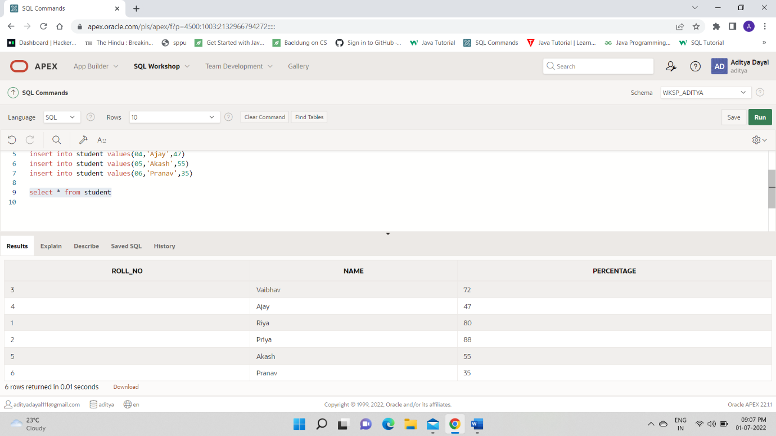

DECLARE

RNO student.roll_no%type:=:RNO;

Name_s student.name%type;

Percent student.percentage%type;

BEGIN

select name,percentage into Name_s,Percent from student where roll_no=RNO;

dbms_output.put_line('Rollno:'||RNO);

dbms_output.put_line('Name:'||Name_s);

dbms_output.put_line('Marks:'||Percent);

dbms_output.put_line('Grade:');

if Percent >= 80.00 then

dbms_output.put_line('A+');

elsif (Percent >= 70.00 and Percent <80)then

dbms_output.put_line('A');

elsif( Percent >= 60.00 and Percent <70) then

dbms_output.put_line('B+');

elsif (Percent >= 50.00 and Percent <60) then

dbms_output.put_line('B');

elsif (Percent >= 40.00 and Percent <50)then

dbms_output.put_line('C');

else

dbms_output.put_line('Fail');

END IF;

EXCEPTION

WHEN NO_DATA_FOUND THEN

dbms_output.put_line('No student found');

WHEN TOO_MANY_ROWS THEN

dbms_output.put_line('Multiple students with same rollno.');

END

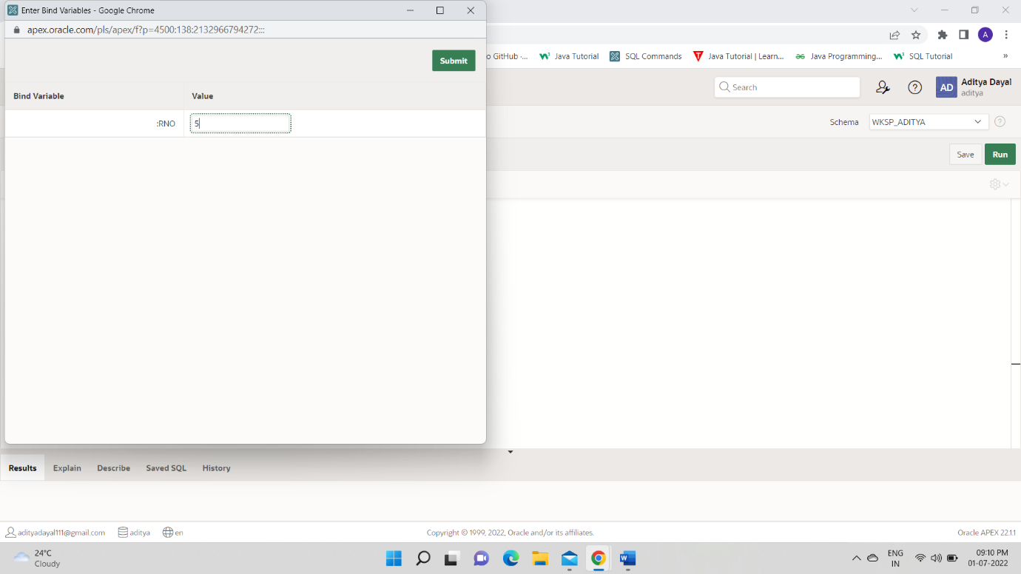

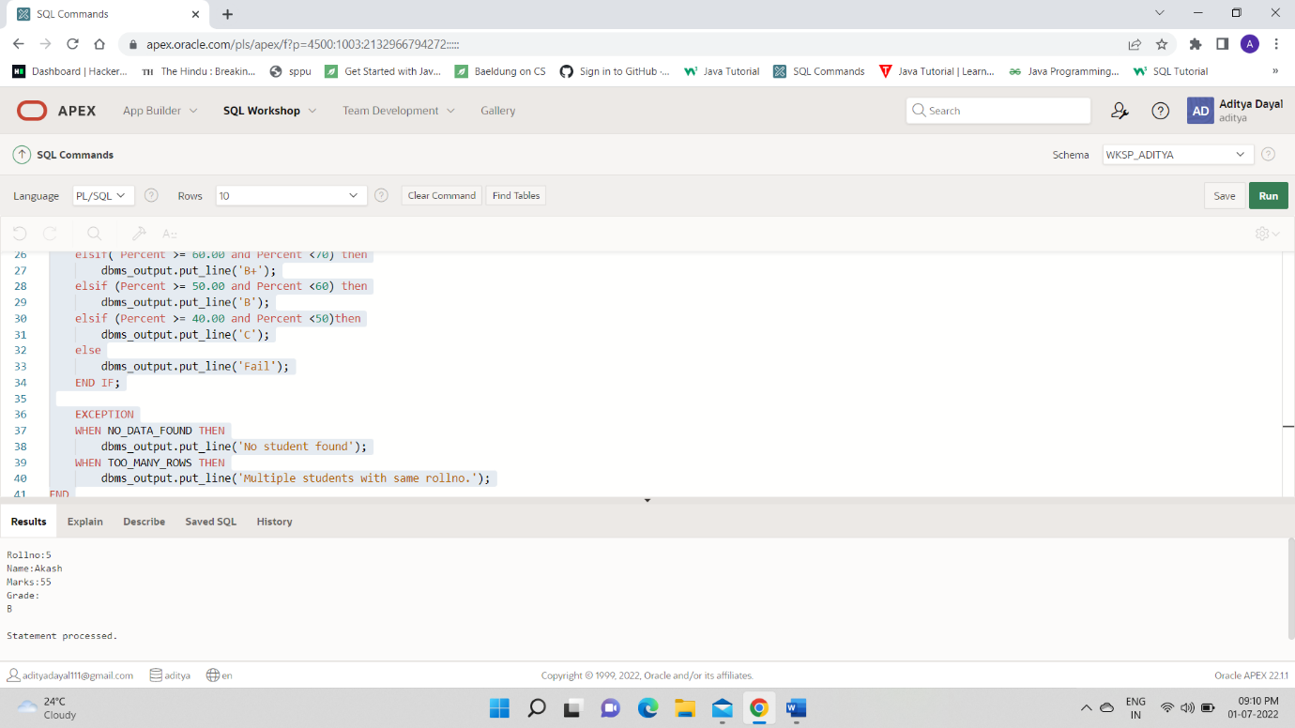

2. Write a PL/SQL block for following requirement and handle the exceptions. Roll no. of student will be entered by user. Attendance of roll no. entered by user will be checked in student table. If attendance is less than 75% then display the message “Term not granted” and set the status in Student table as “D”. Otherwise display message “Term granted” and set the status in Student table as “ND”

Code:

create table student(roll_no int primary key, name varchar2(20), attendance int, status varchar(20));

insert into student values(01,'Riya',80,'')

insert into student values(02,'Priya',88,'')

insert into student values(03,'Vaibhav',72,'')

insert into student values(04,'Ajay',47,'')

insert into student values(05,'Akash',55,'')

insert into student values(06,'Pranav',35,'')

select * from student



DECLARE

RNO student.roll_no%type:=:RNO;

atten student.attendance%type;

BEGIN

select attendance into atten from student where roll_no=RNO;

IF atten<75 THEN

dbms_output.put_line('term not granted');

update student set status='D';

ELSE

dbms_output.put_line('term granted');

update student set status='ND';

END IF;

END;

